1. **INTRODUCTION**

Infrared (IR) and visible image fusion is an important technique in multi-sensor information fusion applications. Since IR sensors are able to capture thermal information in a scene that is not directly seen by human eyes, they can more clearly detect some objects in low-light, occlusion and adverse weather conditions. Visible imagery normally provides more details of the scene in the visible spectrum, and also presents more natural intensities and contrasts that are consistent with human visual perception. Integrating IR and visible information into a fused image allows us to construct a more complete and accurate description of the scene. However, due to heat emissions and differing spectral sensitivities, the relative luminance response in the IR spectrum is quite inconsistent with that in the visible spectrum, which makes the IR imagery hard to be interpreted. As a result, the fusion result of IR and visible imageries may also be visually unpleasing for human observers. Therefore, besides determining the best way to take full advantage of all information of the two source images in the fusion process, a more significant task should be to make the fused image easy to be interpreted, and thus can lead to better situation awareness.

In this paper, we present a novel multi-scale fusion method based on a hybrid MSD transform (hybrid-MSD) to achieve better fusion results for human visual perception. Unlike the previous MSD trans-forms that attempt to capture more directional information with comparatively more complex filters, the hybrid-MSD decomposes the source image into texture details and edge features at multiple scales by jointly using multi-scale Gaussian and bilateral filters. In a perceptual evaluation of different image fusion schemes, To indicate that the IR imagery serves best for target detection and recognition, whereas the visible imagery contributes most to global scene awareness. Our method manages to employ the hybrid-MSD as well as a novel asymmetrical multi-scale fusion scheme to inject the important IR spectral features into the visible image, while preserving (or properly enhancing) important perceptual cues of the background scenery and details captured from the visible spectrum. Thus, it would lead to perceptually better fusion results for human interpretation.

1. **LITERATURE SURVEY**
2. **Title:** "Infrared and visible image fusion with the use of multi-scale edge-preserving decomposition and guided image filter”

**Author:** Wei Gan, Xiaohong Wu, Wei Wu, Xiaomin Yang, Chao Ren, Xiaohai He, Kai Liu

**Publication:** ELSEVIERInfrared Physics & Technology, Volume 72, September 2015, Pages 37–51

* In this paper a novel IR and VIS image fusion framework is proposed by combining multi-scale decomposition and guided filter. The proposed scheme could not only preserve the details of source IR and VI images but could also suppress the artifacts effectively by combining the advantages of multi-scale decomposition and guided filter.
* First, both IR and VIS images are decomposed with a multi-scale edge-preserving filter. Saliency maps of IR and VIS images are then calculated on the basis of phase congruency. Subsequently, the guided filtering is adopted to generate weighting maps. Finally, the resultant image is reconstructed with the weighting maps. Phase congruency (PC) rather than Laplace operator is adopted in this study to obtain better saliency maps, which improves the performance of the proposed method. Representative experiments show that the proposed method outperforms existing methods in image quality.

1. **Title:** "An adaptive fusion approach for infrared and visible images based on NSCT and compressed sensing"

**Author:** Qiong Zhang , Xavier Maldague

**Publication:** ELSEVIER Infrared Physics & Technology, Volume 74, January 2016, Pages 11–20

* A novel non-subsampled contourlet transform (NSCT) based image fusion approach is proposed for the fusion computation of infrared and visible images.
* In the proposed fusion process, the pre-enhanced infrared image and the visible image are decomposed into low-frequency subbands and high-frequency subbands, respectively, via the NSCT method as a first step. The low-frequency coefficients are fused using the adaptive regional average energy rule, the highest-frequency coefficients are fused using the maximum absolute selection rule. They are fused using the adaptive-Gaussian regional standard deviation rule, and then recovered by employing the total variation based gradient descent recovery algorithm.
* Compared with wavelet, contourlet, or any other multi-resolution analysis method, NSCT has many evident advantages, such as multi-scale, multi-direction, and translation invariance.

1. **Title:** "Technique for infrared and visible image fusion based on non-subsampled shearlet transform and spiking cortical model"

**Author:** Weiwei Kong , Binghe Wang , Yang Lei

**Publication:** ELSEVIER Infrared Physics & Technology, Volume 71, July 2015, Pages 87–98

* The existing techniques commonly cannot gain good fusion performance and acceptable computational complexity simultaneously. This paper proposes a novel image fusion approach that integrates the non-subsampled shearlet transform (NSST) with spiking cortical model (SCM) to overcome the above drawbacks.
* Compared with current popular multi-resolution analysis tools such as NSCT, NSST owns much lower computational costs and better sparse representations.
* The proposed method is promising, and it does significantly improve the fusion quality in both aspects of subjective visual performance and objective comparisons compared with other current popular ones.

1. **Title:** "A fast fusion scheme for infrared and visible light images in NSCT”

**Author:**Chunhui Zhao , Yunting Guo, Yulei Wang

**Publication:** ELSEVIER Infrared Physics & Technology, Volume 72, September 2015, Pages 266–275

* A novel fusion algorithm named pixel information estimation is proposed, which determines the weights by evaluating the information of pixel and is well applied in visible light and infrared image fusion with better fusion quality and lower time-consumption Non-subsampled contourlet transform(NSCT) is also proposed in this paper to improve the computational efficiency.
* NSCT is unacceptable due to its inefficient implementation, time-consuming, which limits its development. Combine the SR theory and multi-scale transform (MST), adopt the SR-based fusion rule for the low-pass bands and obtained a better fusion result, but the problem of timeliness is still under resolution.
* To solve the timeliness problem, this paper presents a novel fusion algorithm based on a fast NSCT realization.

1. **METHODOLOGY**

The proposed approach comprises of two steps:

1. **The hybrid-MSD based on Gaussian and bilateral filters**

2. **Infrared and visible image fusion based on the hybrid - MSD**

*2.1.Small and large-scale combinations.*

*2.2.Base level combination.*

1. **The hybrid-MSD based on Gaussian and bilateral filters**

* Gaussian and bilateral filters are both known as important filter-ing methods extensively used in image processing applications. The Gaussian filteris one of the basic tools for noise reduction and image smoothing.
* Gaussian smoothing is used as a pre-processing stage in computer vision algorithms in order to enhance image structures at different scales see scale space representation and scale space implementation.
* A bilateral filter is a non-linear, edge-preserving and noise-reducing smoothing filter for images. The intensity value at each pixel in an image is replaced by a weighted average of intensity values from nearby pixels.
* A Gaussian function denoted as *gσ(x)=exp(−x2/σ2)*
* The bilateral filtering of image ***I*** *at pixel* ***p*** is performed as***:***

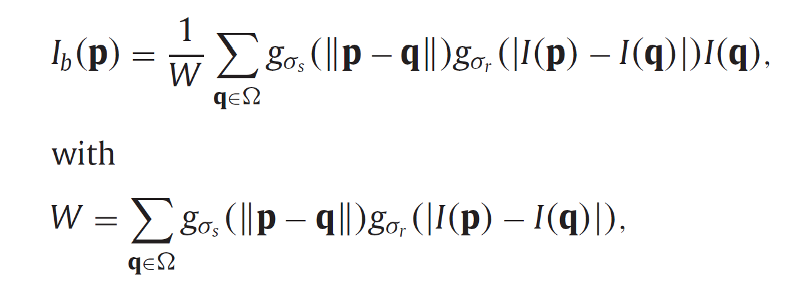

where *σ* *s* and *σ* *r* are the standard deviations of the spatial and range Gaussians, which control the influences of neighboring pixel **q** in terms of spatial and intensity differences, respectively. ***∈*** *R*2 rep-resents the image domain

Assuming *Ig* is the corresponding Gaussian filtered image that is computed by solely using the spatial Gaussian *gσs* *,*we can see that *Ib* contains certain additional edge information compared with *Ig*. Consequently, we can obtain the removed fine-scale texture details *D*0 and the additional edge features *D*1 retained in *Ib* by the following subtractions respectively:

|  |
| --- |
| *D*0***=*** *I* ***−*** *Ib,* |

*D*1***=*** *Ib* ***−*** *Ig.*

The decomposition enables to separate image texture details from a base layer. This two-scale decomposition has been used to various image processing applications via information manipulating on different layers separately, such as high dynamic range compression, tone management, digital photography and relighting. In order to enhance the shape and surface details of an object from multi-light image collections, Fatal et al. extend it into a multi-scale decomposition and successfully avoid the halo artifacts usually introduced by the traditional Laplacian pyramid. In addition to the decomposition, we also use the decomposition since it allows separating large-scale edge features from the fine-scale texture details. Furthermore, we generalize this hybrid decomposition into a multi-scale representation in a manner that is similar to the multi-scale bilateral decomposition presented in, and then demonstrate how this proposed hybrid-MSD can be used to fuse the infrared and visible images to allow for better visual perception.

**2. Infrared and visible image fusion based on the hybrid-MSD**

Visible images often contain more fine-scale details than the corresponding infrared images, in which the thermal information is usually captured as coarser-scale structures or features. Therefore, there usually exists a large scale difference between the infrared and visible images, which can be measured in scale-space. In addition, infrared images often present unnaturally high contrasts and intensities on the objects with relatively higher temperature than the surroundings. The luminance responses and contrasts of the same scene in the infrared and visible images can also be different. For these reasons, decomposing and then merging the two source image information directly by employing conventional MSDs without reliable feature selection may not produce a pleasant fusion result for human observation.

Fig. 4 presents a three-level decomposition of the “UN Camp” infrared image (see Fig. 1(a)) obtained by the hybrid-MSD transform, in which the absolute values |*D*(*j*, 0)| and |*D*(*j*, 1)| *(* *j* ***=*** 1*,* 2*,* 3*)* are concerned. We can see that significant IR spectral features get particularly high responses in |*D*(*j*, 1)|. Especially at the largest scale level these features can be even clearly identified (see Fig. 4(f)). This is because the prominent IR spectral information usually emerges as large-scale features in the infrared image and achieves high relative luminance responses which contain stronger edges. As a result, it is more associated with the large-scale edge features obtained in the hybrid-MSD. Thus, this decomposition allows us to better capture the multi-scale IR spectral features in the infrared image. Moreover, the hybrid-MSD is able to separate fine-scale texture details from large-scale edge features, which is essential for the fusion of infrared and visible images since we can better take advantage of the texture details from the visible image.

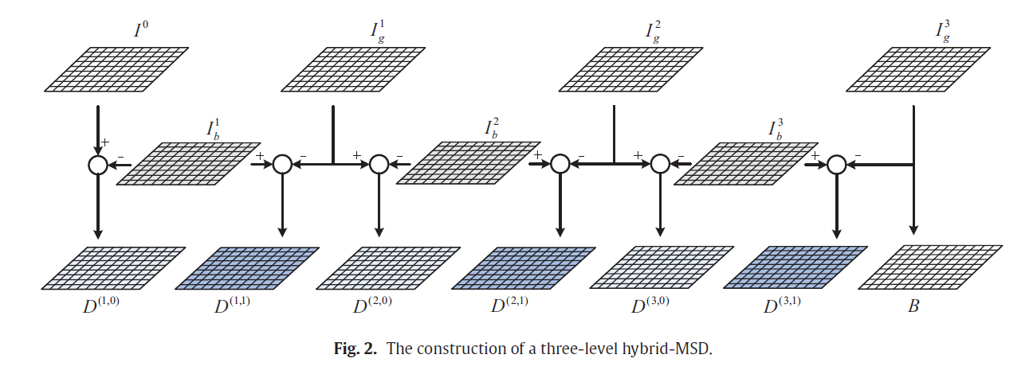

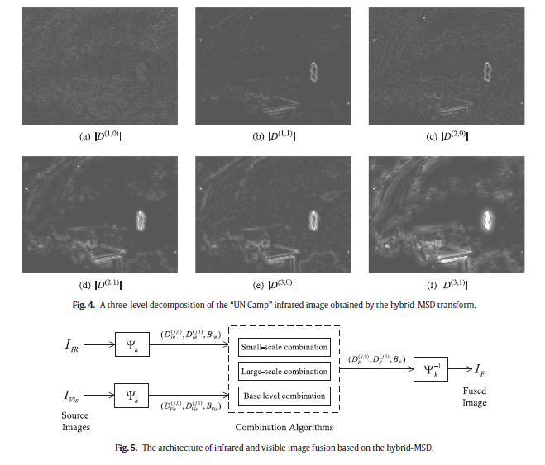

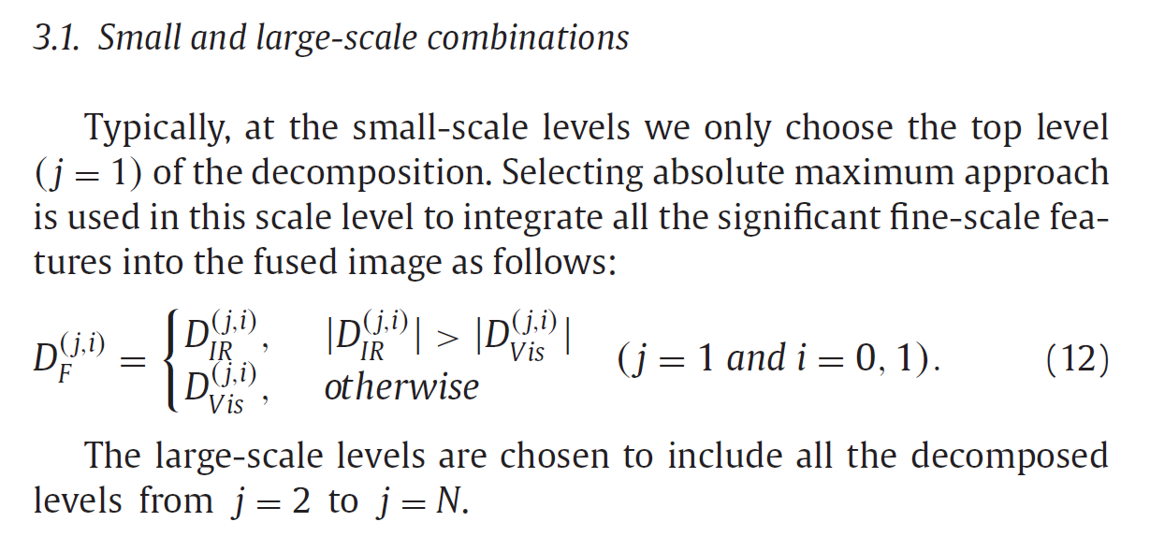

**2.2.Base level combination**

The base image obtained by a MSD contains the coarsest scale information. Theoretically, we can keep applying the decomposing process until the mean information of the source image is obtained.

However, it is unnecessary in practice since the base image containing a certain amount of residual low-frequency information can well be employed to control the overall look of the fused image. Also, it requires large number of decomposition levels which would drastically increase the computational work.

Another important function of the base image in a multi-scale representation is that it generally provides the support information for the higher-frequency sub bands. They are closely associated with each other in scale-spaces. So it is reasonable that the construction of the fused base image would also be related to the higher-level decomposed information in the fusion process.

As a result, we combine the base images by taking account of the higher-level weighting coeﬃcients as follows:

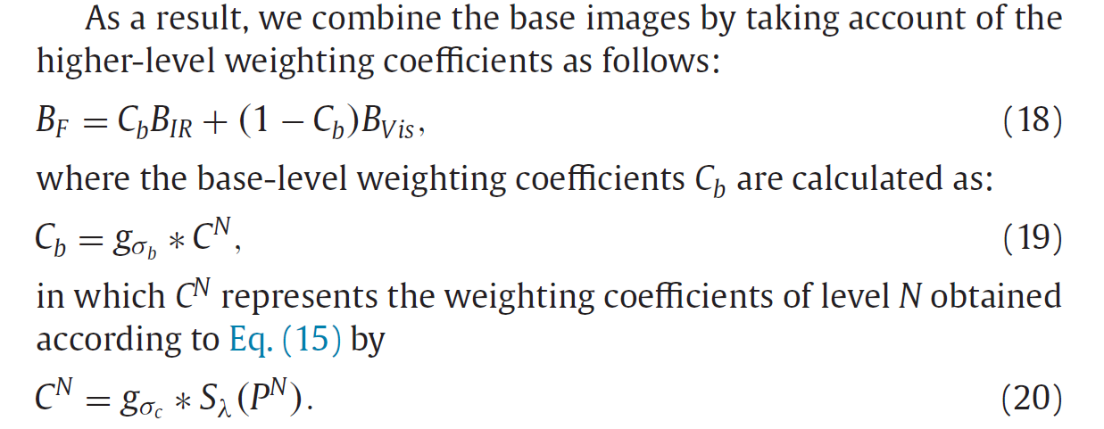

1. **EXPERIMENTAL RESULTS**

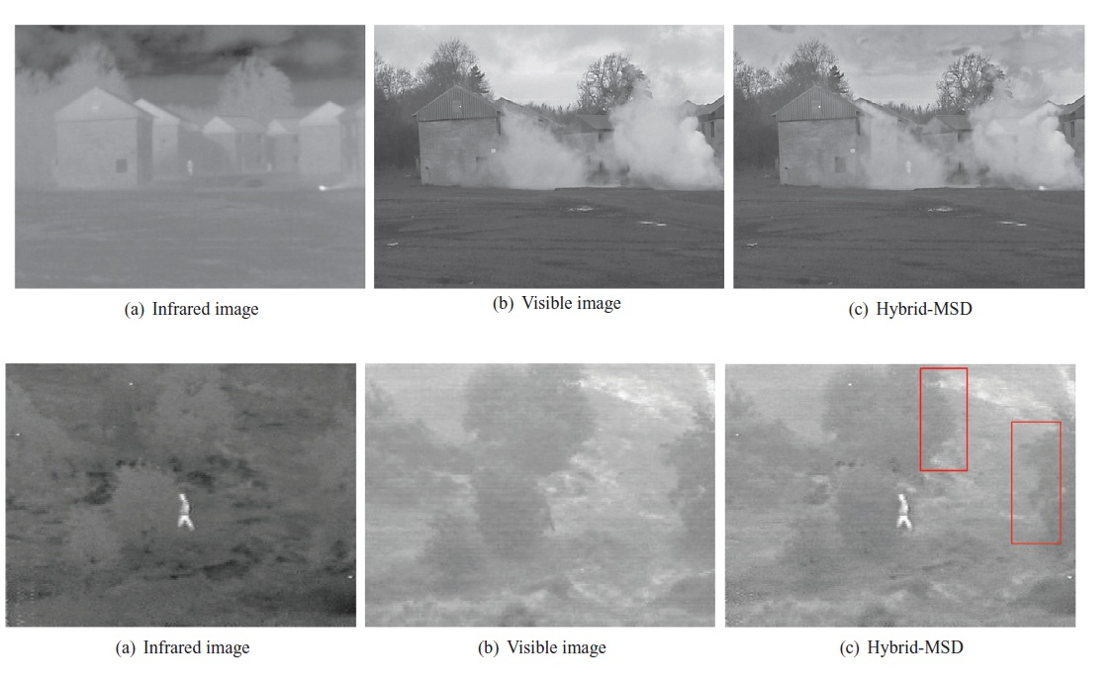

**6.CONCLUSION**

In this paper, we propose a novel multi-scale image fusion method based on a hybrid multi-scale decomposition (namely hybrid-MSD) transform for perceptual fusion of the infrared and visible images. Unlike conventional MSD transforms, the hybrid-MSD integrates multi-scale Gaussian and bilateral filters to decompose the source images into multi-scale texture details and edge features. Particularly, it can be used to identify and select important IR spectral features from the infrared image to inject them into the visible image.

By further employing different combination algorithms adaptively ac-cording to different information scale levels in the fusion process, we can preserve or properly enhance the background scenery and de-tails from the visible image which provide important perceptual cues for human observation. Experimental results demonstrate that the proposed fusion method is able to provide perceptually better fusion results compared with various other pixel-based multi-scale fusion algorithms.

**7.REFERENCES**

1. Wei Gan, Xiaohong Wu, Wei Wu, Xiaomin Yang, Chao Ren, Xiaohai He, Kai Liu-"Infrared and visible image fusion with the use of multi-scale edge-preserving decomposition and guided image filter”-ELSEVIER Infrared Physics & Technology, Volume 72,Pages 37–51 September 2015,
2. Qiong Zhang , Xavier Maldague-"An adaptive fusion approach for infrared and visible images based on NSCT and compressed sensing"-ELSEVIER Infrared Physics & Technology, Volume 74,Pages 11–20, January 2016
3. Weiwei Kong , Binghe Wang , Yang Lei-"Technique for infrared and visible image fusion based on non-subsampled shearlet transform and spiking cortical model"-ELSEVIER Infrared Physics & Technology, Volume 71,Pages 87–98, July 2015
4. Chunhui Zhao , Yunting Guo, Yulei Wang-"A fast fusion scheme for infrared and visible light images in NSCT”-ELSEVIER Infrared Physics & Technology, Volume 72, Pages 266–275, September 2015
5. Zhiqiang Zhou, Bo Wang, Sun Li, Mingjie Dong-"Perceptual fusion of infrared and visible images through a hybrid multi-scale decomposition with Gaussian and bilateral filters"-ELSEVIER Information Fusion, Volume 30, Pages 15–26, July 2016,